- Graphical Methods

1. The equation of a circle is given as
2x² + 2y² – 8x + 5y + 10 = 0. Find the radius of the circle and the coordinates of its centre. (3 mks)
2. The equation of a circle is given by x² + 4x + y² – 5 = 0. Find the centre of the circle and its
radius.
3. The equation of a circle is x² + y² + 6x – 10y – 2 = 0. Determine the co-ordinates of the
centre of the circle and state its radius

4. In the diagram below ABE is a tangent to a circle at B and DCE is a straight line.
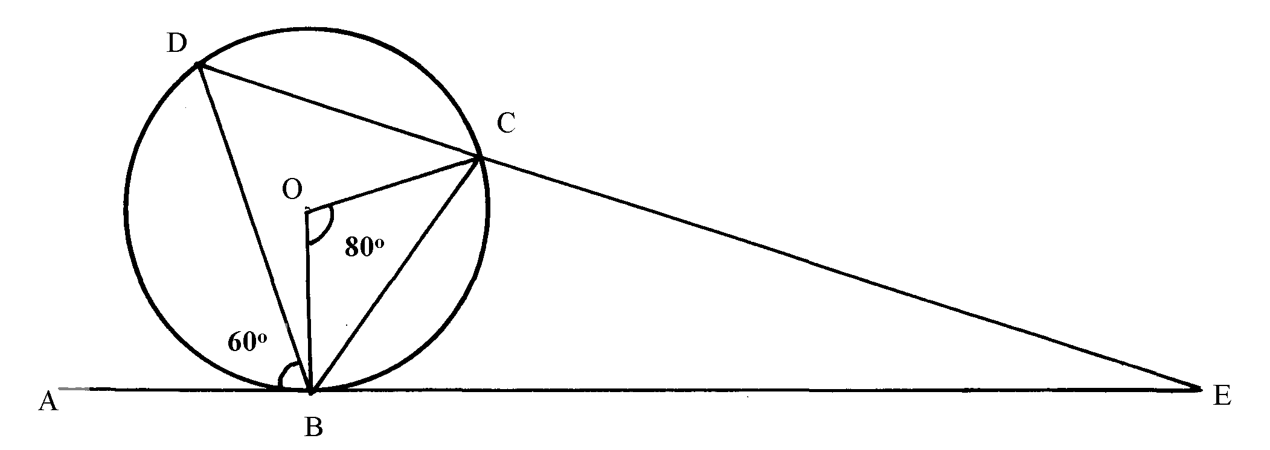
If ABD = 60º, BOC = 80º and O is the centre of the circle, find with reasons ∠BEC

5. Obtain the centre and the radius of the circle represented by the equation:
x² + y² – 10y + 16 = 0

6. Complete the table below, for the function y = x³ + 6x² + 8x
x | -5 | -4 | -3 | -2 | -1 | 0 | 1
x³ | -125 |  | -27 | -8 |  | 0 | 1
6x² |  | 96 | 54 |  | 6 | 0 | 6
8x | -40 |  | -24 |  |  | 0 | 8
y |  |  | 3 | 0 |  | 0 | 15
(a) Draw a graph of the function y = x³ + 6x² + 8x for – 5≤ x ≤1 and use the graph to estimate
the roots of the equation x³ + 6x² + 8x = 0
(b) Find which values of x satisfy the inequality x³ + 6x² + 8x -1 > 0

7. Sketch the curve of the function y = x³– 3x + 2 showing clearly minimum and maximum points
and the y – intercept.

8. Show that 4y² + 4x² = 12x – 12y + 7 is the equation of a circle, hence find the co-ordinates
of the centre and the radius

9. Two variables R and P are connected by a function R = KP^{n} where K and n are constants.
The table below shows data involving the two variables
P | 3 | 3.5 | 4 | 4.5 | 5
R | 36 | 49 | 64 | 81 | 100

(a) Express R = KP^{n} in a linear form
(b) Draw a line graph to represent the information above
(c) Find the values of constants K and n
(d) Write down the law connecting R and P
(e) Find the value of P when R = 900

10. A circle of radius 3cm has the centre at (-2, 3) . Find the equation of the circle in the
form of x² + y² + Px + qy + c = 0

11. In an experiment, the values of two quantities V and T were observed and the results recorded as
shown below.

V | 0 | 2 | 4 | 6 | 8 | 10
T | 0.49 | 0.30 | 0.24 | 0.20 | 0.16 | 0.137
T =
It is known that T and V are related by a law of the form a
b + V
where a and b are constants.
a) Draw the graph of I against V
T
b) Use your graph to find;
i) The values of a and b.
ii) V when T = 0.38
iii) T when V = 4.5

12. Find the equation of the tangent to the curve y = 2x³ + x² + 3x – 1 at the point (1, -5)
expressing you answer in the form y = mx + c

13. Given that :- 243 = (81)⁻¹ x ( ¹/₂₇) ^{x} determine the value of x
14. Show that 3x² + 3y ² + 6x – 12y - 12 = 0 is an equation of a circle hence state the radius and
centre of the circle

15. (a) Fill in the table below for the function y = -6 + x + 4x² + x³ for -4 ≤ x ≤ 2

x | -4 | -3 | -2 | -1 | 0 | 1 | 2
-6 | -6 | -6 | -6 | -6 | -6 | -6 | -6
x | -4 | -3 | -2 | -1 | 0 | 1 | 2
4x² |  |  | 16 |  |  | 4
x³
y
(b) Using the grid provided draw the graph for y = -6 + x + 4x² + x³ for -4≤ x ≤ 2
(c) (i) Use the graph to solve the equations:-
(i) x³ + 4x² + x – 4 = 0
(ii) -6 + x + 4x² + x³ = 0
(iii) -2 + 4x² + x³ = 0

16. The table below shows the results obtained from an experiment to determine the relationship
between the length of a given side of a plane figure and its perimeter

Length of side ι (cm) | 1 | 2 | 3 | 4 | 5
Perimeter P(cm) | 6.28 | 12.57 | 18.86 | 21.14 | 31.43

(a) On the grid provided, draw a graph of perimeter P, against ι
(b) Using your graph determine;
(i) the perimeter of a similar figure of side 2.5cm
(ii) the length of a similar figure whose perimeter is 9.43cm
(iii) the law connecting perimeter p and the length ι
(c) If the law is of the form P = 2kι + c where k and c are constants, find the value of k

17. In an experiment with tungsten filament lamp, the reading below of voltage (V) current (I),
power (P) and resistance (R)were obtained. It was established that P was related to R by
a law P = a R^{n} – 0.6. Where a and n are constants.
V | 1.30 | 2.00 | 2.80 | 4.40 | 5.70
I | 1.50 | 1.80 | 2.10 | 2.50 | 2.90
P | 0.73 | 2.05 | 3.28 | 7.44 | 10.62
R | 0.89 | 1.13 | 1.33 | 1.78 | 1.99
Plot a suitable line graph and hence use it to determine the value of a and n
18. Find the gradient of a line joining the centre of a circle whose equation is x² + y² – 6x = 3 – 4y
and a point P(6,7) outside the circle..

19. a) Complete the table below for the function y = -x³ + 2x² – 4x + 2.

x | -3 | -2 | -1 | 0 | 1 | 2 | 3 | 4
-x³ | 27 | 8 |  | 0 |  | -8
2x² | 18 | 8 | 2 | 0
-4x |  | 8 |  | 0 |  |  |  | -16
2 | 2 | 2 | 2 | 2 | 2 | 2 | 2 | 2
y |  | 26 |  | 2 |  | -6 |  | -46
b) On the grid provided below draw the graph of -x³ + 2x² – 4x + 2 for - 3 ≤ x ≤ 4.
c) Use the graph to solve the equation -x³ + 2x² – 4x + 2 = 0.
d) By drawing a suitable line on the graph solve the equation. –x³ + 2x² – 5x + 3 = 0.

20. Determine the turning point of the curve y = 4x³ - 12x + 1. State whether the turning
point is a maximum or a minimum point.

21. (a) Complete the table below for the equation of the curve given by y = 2x³ – 3x² + 1
X | -2 | -1.5 | -1 | -0.5 | 0 | 0.5 | 1 | 1.5 | 2 | 2.5 | 3
2x³ | -16 |  | -2 |  | 0 |  | 2 |  | 16
-3x² | -12 |  |  | 0.75 | 0 | -0.75 |  |  |  |  | -27
1 | 1 |  |  |  | 1
y | -27 | -12.5 |  |  | 1 |  |  |  |  |  | 13.5
(b) Use the table to draw the graph of the function y = 2x³ – 3x² + 1
c) Use your graph to find the values of x for :-
(i) y > 0
(ii) The roots of the equation 2x³ – 3x² + 1 = 0
(iii) 2x³ – 3x² = 9

22. Find the radius and the centre of a circle whose equation is :
2x² + 2y² – 6x + 10y + 9 = 0

